Search Warrants- During Court Hours
Applications in the Midlands Region of HMCTS

(This protocol covers applications made by police forces covering the counties of Derbyshire, Leicestershire, Lincolnshire, Northamptonshire, Nottinghamshire, Staffordshire, Warwickshire, West Mercia, the West Midlands, Immigration, Mental Health Warrant Applicants and NCA).

Guidance to Applicants under the Mental Health Act 1983

Introduction

This guidance is produced to assist Applicants, in conjunction with HMCTS, to effectively manage the efficient and effective administration of search warrant applications made across the Midlands Region. This guidance should be read and followed in conjunction with the following documents:-

- The step-by-step guide for using the scheme- page 3

- Joining telephone hearing by CVP- page 6

- Team-Up Guidance for booking an application slot- page 11

- Pro Forma Applications and Warrants- page 22

Background to the scheme

Following a Law Commission Review of the search warrant processes used across England & Wales (https://www.lawcom.gov.uk/document/search-warrants/) there is a need to review the arrangements that are in place and to adopt a nationally approved system. All HMCTS regions have been instructed to adopt the approach to in-hours search warrant applications which has been piloted by the South East region. This approach has the full support of the Senior Presiding Judge.

A HMCTS project team has established that a regional search warrants scheme has positive benefits to both applicants and HMCTS. The Midlands region has since 2017 had a regional search warrant scheme whereby all non-urgent applications from all force areas in the Midlands are heard remotely by telephone conference at two courts which sit daily Mon-Fri at Magistrates Courts in the Midlands.

The current system requires email communication at the beginning of the process between the applicant and the court administrative staff to schedule an appropriate slot in the court diary. This step can potentially delay criminal investigations where time is often critical if seizure of items is to be successful.

Where the applicant identifies that an urgent hearing is needed and the search warrant courts are fully booked up applicants are directed to contact local court houses and attend the court building to make their application. Sometimes courts are able to accommodate warrant applications immediately but other times applicants are kept waiting until there is an appropriate break in the court list or proceedings, and on occasions, they are asked to attend the following day or make their application to the “out of hours” scheme. Sometimes, particularly if late in the day, access to a Justice of the Peace (JP) can be difficult and delay is again caused to the applicant whilst arrangements are made for the application to be heard.

Diverting such applications into court lists disrupts the efficient processing of court business and even where the applicant does not experience a delay, other court users are often kept waiting, whilst the legal adviser and a JP consider the warrant application.

Scheme overview

The scheme will operate in the Midlands Region at dedicated search warrant hearings listed at Magistrates Courts in the Midlands with applicants making their applications via the telephone and paperwork being received and dispatched by secure email.

The scheme will use a web-based booking system. Applicants using a web-based calendar to book in their warrant(s) application on a date and time convenient to them. Police officers can access the calendar 24 hours a day. Applications will be considered between 10.00am and 4:00pm.

Applications, warrants granted and reasons for grant/refusal will be stored securely in an electronic format within a designated search warrant folder. Hard copies of the paperwork will therefore be easily accessible to HMCTS should there be a requirement to produce informations at a future date. The electronic storage system will ensure that storage of the relevant information complies with data security and retention timescales. Only authorised personnel will have access to the secure email box and storage facility.

Legal advisers will be responsible for ensuring the relevant paperwork is both received and dispatched in good order in accordance with the guidance and that all information is correctly stored and filed.

Applications will be initially scrutinised by legal adviser who will then provide advice on matters of law, practice and procedure to the relevant Justice of the Peace, who will be rota’d to consider such applications on any particular day.

This scheme envisages that all warrants will be considered under this scheme unless the scheme is unable to respond quickly enough to an urgent application or the volume of warrants is such that diversion to a location court site is preferable. This scheme will operate in conjunction with and to compliment the “out of hours” search warrant scheme.

Benefits of the scheme

It is envisaged that the scheme will:-

- Ensure that warrant applications, including urgent applications, are considered in a timely manner in accordance with the law and best practice;

- Enable the very vast majority of applications to be considered without disruption to the efficient processing of other court business;

- Provide an enhanced customer service to applicants within working hours and reduce both the uncertainty and delay that can be experienced when arranging to make a warrant application;

- Make best use of police, legal adviser and judicial time;

- Make best use of HMCTS estate by removing such applications from courtrooms; and

- Reduce the administrative tasks surrounding the processing, filing and storage of such applications by making best use of electronic and digital solutions.

Procedure and guidance for the applicants wishing to apply for a search warrant(s).

Applications for search warrants where the application is to be made during the working hours of 10.00 am to 4:00pm

- Making a Booking: Book in your application using the web-based Team-Up calendar. Bookings can be made at anytime as the calendar is available 24 hours a day, 7 days a week through both a desktop web browser and a mobile app.

- The Team up Calendar can be accessed by pasting the following link into your internet browser.

https://teamup.com/ksfemp7xw313js59us
See the Team-Up Guidance (Page 10) for assistance

- When you can book a hearing: Applicants can choose the date and time of their application hearing from the available time slots in the calendar. Bookings can be made on the day you wish the application to be heard if there is space available and the time slot has not passed. It is feasible therefore that applications can be made on the same day as the application is to be heard if there is hearing time available in the calendar. Applicants are encouraged however to book in advance thus helping the court to effectively manage applications and incorporate urgent applications at short notice.

Ensure that the correct slot duration is booked.
- Each application slot is 20 minutes for a standard search warrant application, i.e. 1 Application in respect of up to 3 linked premises.
- If your application covers 4 or more premises you will need to book two 20 minute slots to accommodate the application.
- Do not leave any short gaps in the calendar. If the last search warrant before yours is booked in to finish at 10:20 then schedule yours to start straight afterwards at 10:20.

Obtain your booking reference as below and ensure this is recorded on the calendar at the time your booking is made

e.g. MH 11-10-2021 Harrison 1

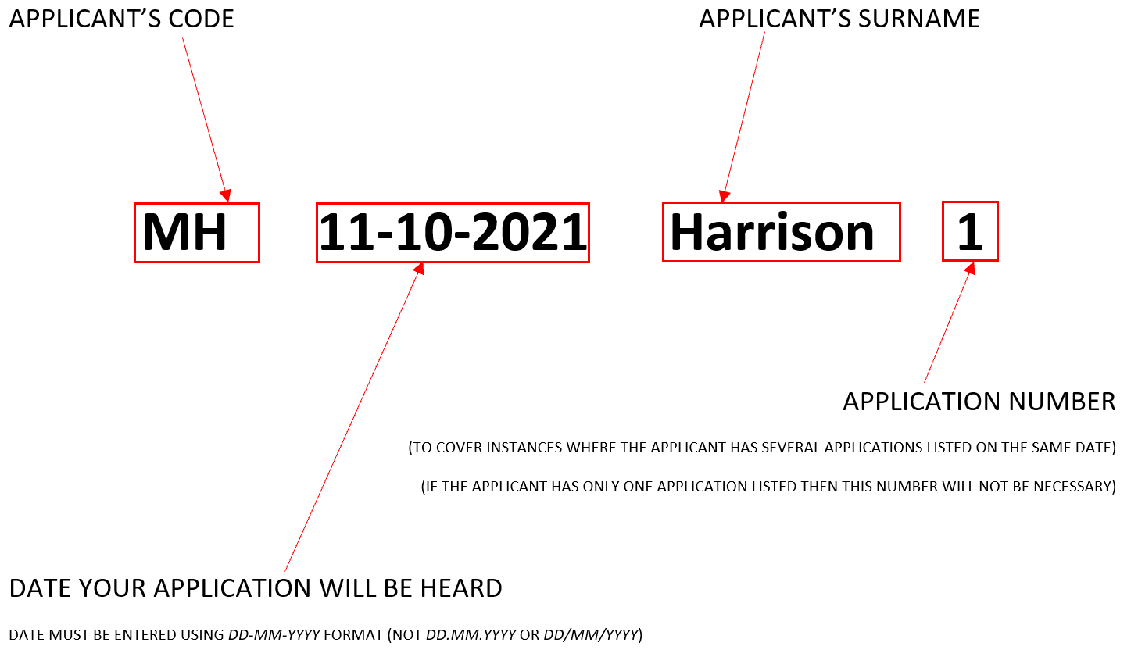

It is imperative that you do not include any personal details about the warrant (premises address, occupier name) on the Team Up calendar as the calendar is not on a secure website. It is also best practice not to include any information which could identify that this is a court calendar i.e. court name or anything that identifies this as a warrant application.

- Where the application is Urgent requiring a hearing on the same day and there are no slots available the applicant should contact the Midlands Search Warrant admin team by phone on 07815 992400 to request one of the slots set aside for urgent warrants on the day.

There are 8 daily urgent search warrant slots (marked on the TeamUp calendar as ‘Space reserved for Urgent Applications’) and timed as follows:
12:20-12:40 (x2)
12:40-13:00 (x2)
14:00-14:20 (x2)
16:00-16:20 (x2)

- Submitting Applications: All relevant paperwork must be submitted by email at the time the booking is made or as soon as practicable thereafter to the secure email box.

DN-SearchWarrants@justice.gov.uk

For bookings that are made in advance of the court date the cut-off point for paperwork to be submitted is 12:00 noon the working day prior to the hearing.

An automated response will be sent from the above email address when an email has successfully been received. If you do not receive this automated response, your email has not been received therefore please check the address for errors.

Bookings for which there is no relevant paperwork submitted by will not be accommodated by the court.

All documents MUST be in Microsoft Word format to allow amendments to be made and Justice’s reasons/signature to be recorded
(the court will not accept paperwork in PDF format)

You must provide;

- The completed Application signed digitally by the applicant officer and the authorising officer

- One copy of the draft search warrant in respect of each Premises headed Applicant’s Copy/ Occupier’s Copy

- The Application and Warrant should be headed as being made at the Court address below (as this is the administrative site receiving the application)

Southern Derbyshire Magistrates’ Court, 27 St Mary's Gate, Derby DE1 3JR
Telephone number: 01332 362000

See Annex to this Guidance (page 19) for Word proforma copies of:

- Application under section 135 of the mental Health Act 1983
- Warrant under section 135 of the mental Health Act 1983

  - Check that the correct booking reference has been used on all paperwork and that you have supplied your contact phone number details. This is the telephone number on which the court will contact you at the application hearing time.
  - Check that the paperwork has been submitted from a secure email address. This is the email address that the court will return your electronically signed warrant if granted and/or reasons for the grant/refusal of the application.
  - If another officer is submitting the application on behalf of the applicant, their email address must be included on the application and cc’d in when the application is sent to the inbox. Both email addresses must be secure email addresses.
  - Check that;
      - only the booking reference appears in the subject heading of the email and as the document titles
      - the booking reference also appears in the title of the attached application/ warrant
(as below)

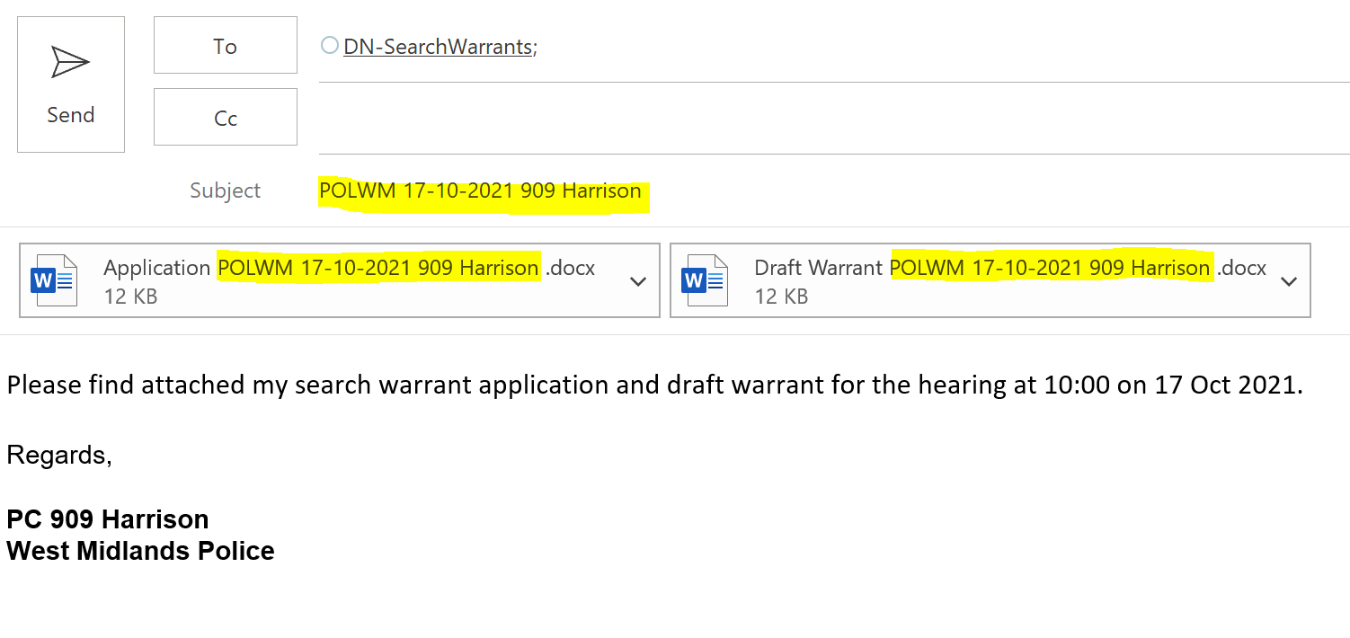
Where paperwork or information is missing, including the booking code, the legal adviser will contact you, at the earliest opportunity, and no later than the application hearing time, by phone or email. You will be advised to re-book your application and re-submit your paperwork.

Whilst every effort will be made to give the applicant as much notice as possible that their application will not be considered due to paperwork error, it is the responsibility of applicants to ensure that their paperwork complies with the requirements of the scheme by submitting the correctly headed documents and in Word format.

- Making the Application: Telephone application over Cloud Video Platform (CVP)

- At the designated application hearing time Applicants must dial 0204 525 7533. This call must be made from the phone number which you have entered in page 1 of your Search Warrant Application.

- An automated message will prompt you to enter 2 numbers, firstly the number for the CVP room you wish to join (followed by the # key) and secondly a PIN code. Please check the TeamUp calendar to confirm which court you have booked your application in and then use the numbers below for the relevant court:

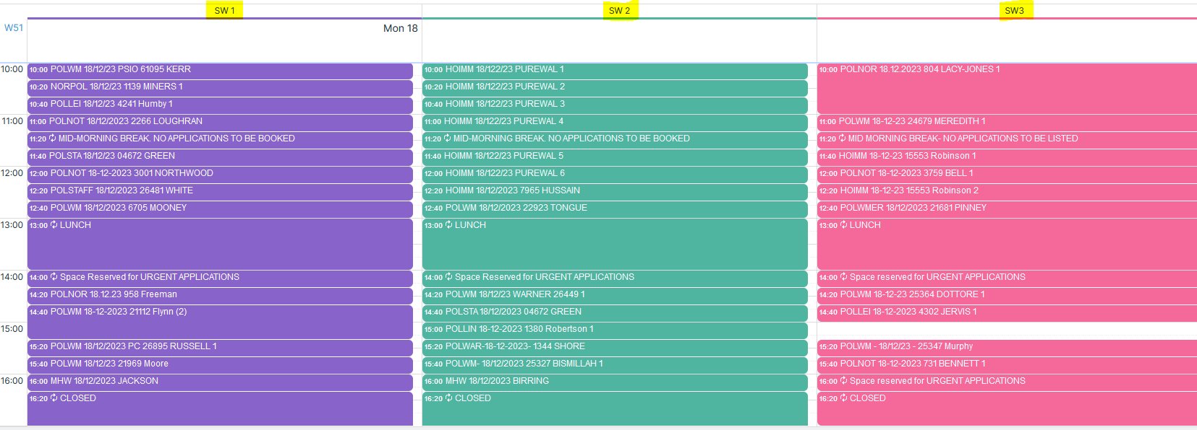

Court SW1
Room Number: 25247178#
Guest PIN: 6024

Court SW2
Room Number: 25975116#
Guest PIN: 9145

Court SW3
Room Number: 25464876#
Guest PIN: 126565

- The CVP room will be locked initially and you will be waiting in the Lobby. When the Legal Adviser who is Hosting the conference is ready you will be added to the conference.

- You will be asked by the legal adviser to verify your identity. You should be able to provide:-

- Booking reference;
- Agency applying;
- Inspector that authorised the application

If the court is satisfied that they are speaking to the applicant, you will be asked to take the oath/affirm and make your application. You will need to have your own holy book ready if taking an oath.

Wording for Oath/ Affirmation

OATH

I (name) swear by almighty god that the evidence I shall give shall be the truth, the whole truth and nothing but the truth. To the best of my knowledge and belief, this application discloses all the information that is material to what the court must decide, including anything that might reasonably be considered capable of undermining any of the grounds of the application.

AFFIRMATION

I (name) do solemnly, sincerely and truly declare and affirm that the evidence I shall give shall be the truth, the whole truth and nothing but the truth. To the best of my knowledge and belief, this application discloses all the information that is material to what the court must decide, including anything that might reasonably be considered capable of undermining any of the grounds of the application.

- It is important that applicants are at an appropriate location to receive the court’s call and to ensure that the information they provide cannot be overheard. It will not be possible to delay the application in order to facilitate the applicant moving to another location.

Only the applicant should be present when making the application. No other person should be present or be able to overhear the application. Any request for any other person to be present with the applicant must be made expressly at the beginning of the application process to the legal adviser and magistrate in the absence of that person. Only where express permission has been sought and granted can that other person then be present. This is to cover situations for example, where applicants are training other members of their team in the making of such applications.

- After the Application has been heard

- If granted

Receiving the Warrant: The Warrant will be electronically signed with the JP’s digital signature and returned electronically by the legal adviser to the applicant’s secure email address. Paperwork will only be dispatched to the email address from which the paperwork was received or if the paperwork was sent on behalf of another person, the email address must have been cc’d in the original email. This email address must match the email address identified in the information supplied.

Only one copy of the warrant will be returned with ‘Occupant/ Applicant’ at the top, this can be crossed through as appropriate by the applicant.

Receiving the endorsed Application: Supporting reasons for granting the warrant and answers the applicant gave to additional questions from the Magistrate will be endorsed on the relevant paperwork and returned to the applicant electronically. This email address must match the email address identified in the application supplied. The returned application should include a record of any additional evidence provided by the applicant as well as the Magistrate’s reasons for grant/refusal.

The Legal Adviser will also save the endorsed Application to a secure location on the HMCTS system together with the signed warrant.

- If refused

Receiving the endorsed Application: Supporting reasons for refusal will be endorsed on the relevant paperwork and returned to the applicant electronically. This email address must match the email address identified in the application supplied. The returned application should include a record of any additional evidence provided by the applicant as well as the Magistrate’s reasons for refusal.

The Legal Adviser will also save the endorsed Application to a secure location on the HMCTS system.

- Return of Executed/ Non-Executed Warrants: Once executed or where the warrant time limit has expired without execution, the applicant MUST return by email the warrant with any relevant information relating to its execution to the secure HMCTS email address;

DN-SearchWarrants@justice.gov.uk

Please ensure that the document is named with the booking reference and not the premises address. The subject field on this email must contain only the original booking reference i.e. MH 11-10-2021 Harrison 1
.
Returned warrants will be electronically filed with the original application. It is therefore imperative that the subject field contains only the original booking reference.

The court will NOT accept any paper copies of executed warrants. This is a digital process from start-to-finish and all executed warrants must be provided digitally by email. If the police’s copy is on paper it should be scanned, converted to PDF and emailed to the court at the address above.

Any hard copy warrants should be stored/destroyed in line with any relevant organisation’s guidance/policy on retention and destruction of confidential documents.

- Out of Hours Applications: If your application is urgent and you need to make your application outside of working hours please refer to the out of hours procedure.

- For Urgent Applications within working hours please follow the normal Team Up booking procedure or if no slots are available contact the emergency administrator number

07815 992400

If the emergency administrator is unable to accommodate your application you should contact your local court admin centre to arrange at time and location for the hearing. You will receive a decision within 30 minutes of your contact via the emergency phone as to whether your application can be accommodated on the digital scheme or whether you will be diverted to a court site.

TEAM UP - BOOKING SEARCH WARRANT SLOTS – MENTAL HEALTH ACT APPLICANTS

- ACCESSING THE CALENDAR
Paste the following link: https://teamup.com/ksfemp7xw313js59us into your web browser.
NB Please do not publicise this link to members of the public or share with outside agencies or police authorities. It is a link specific to Applicants under the Mental Health Act only.

CHANGING THE VIEW

TeamUp occasionally changes the default view when you open up the calendar so that the work of the separate courts appears mixed up as below.

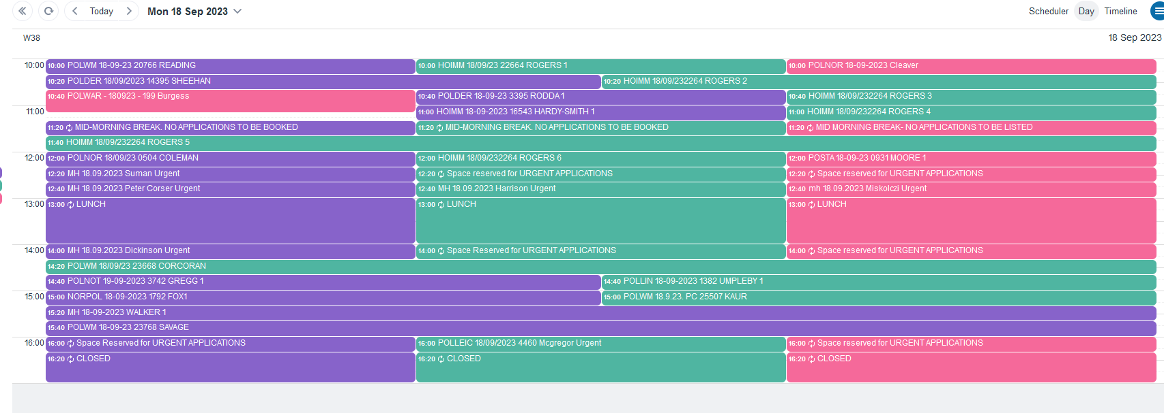

To fix this please Change the view to “Scheduler” and the resolution to “15 mins” as highlighted below.

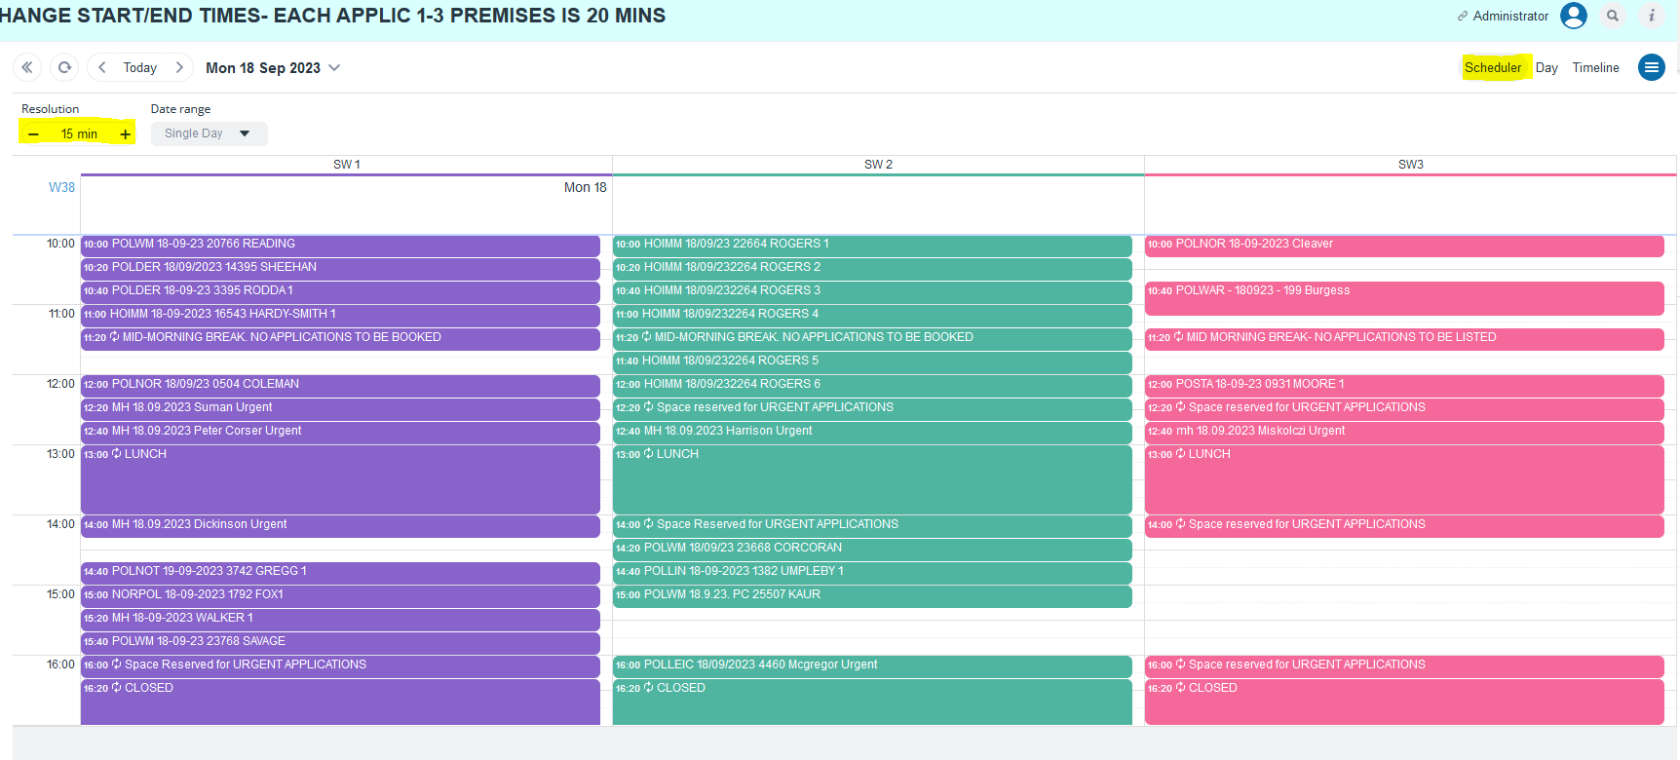

USING THE CALENDAR

Each link has permissions which enable the adding of new events to the calendar and modifications to existing events but only if created using the same link. For example, if a slot has been booked by West Midlands police, then only someone logging in using the West Midlands police link (or the Administrator) can amend or delete the booking, all other police users or other applicants will be able to view the booking as ‘read only’.

The link above will take you to the Calendar for the Midlands Search Warrant Court. You will see that the fact this is the Mental Health Applicants’ link to the calendar is stated in the top-right of the page:
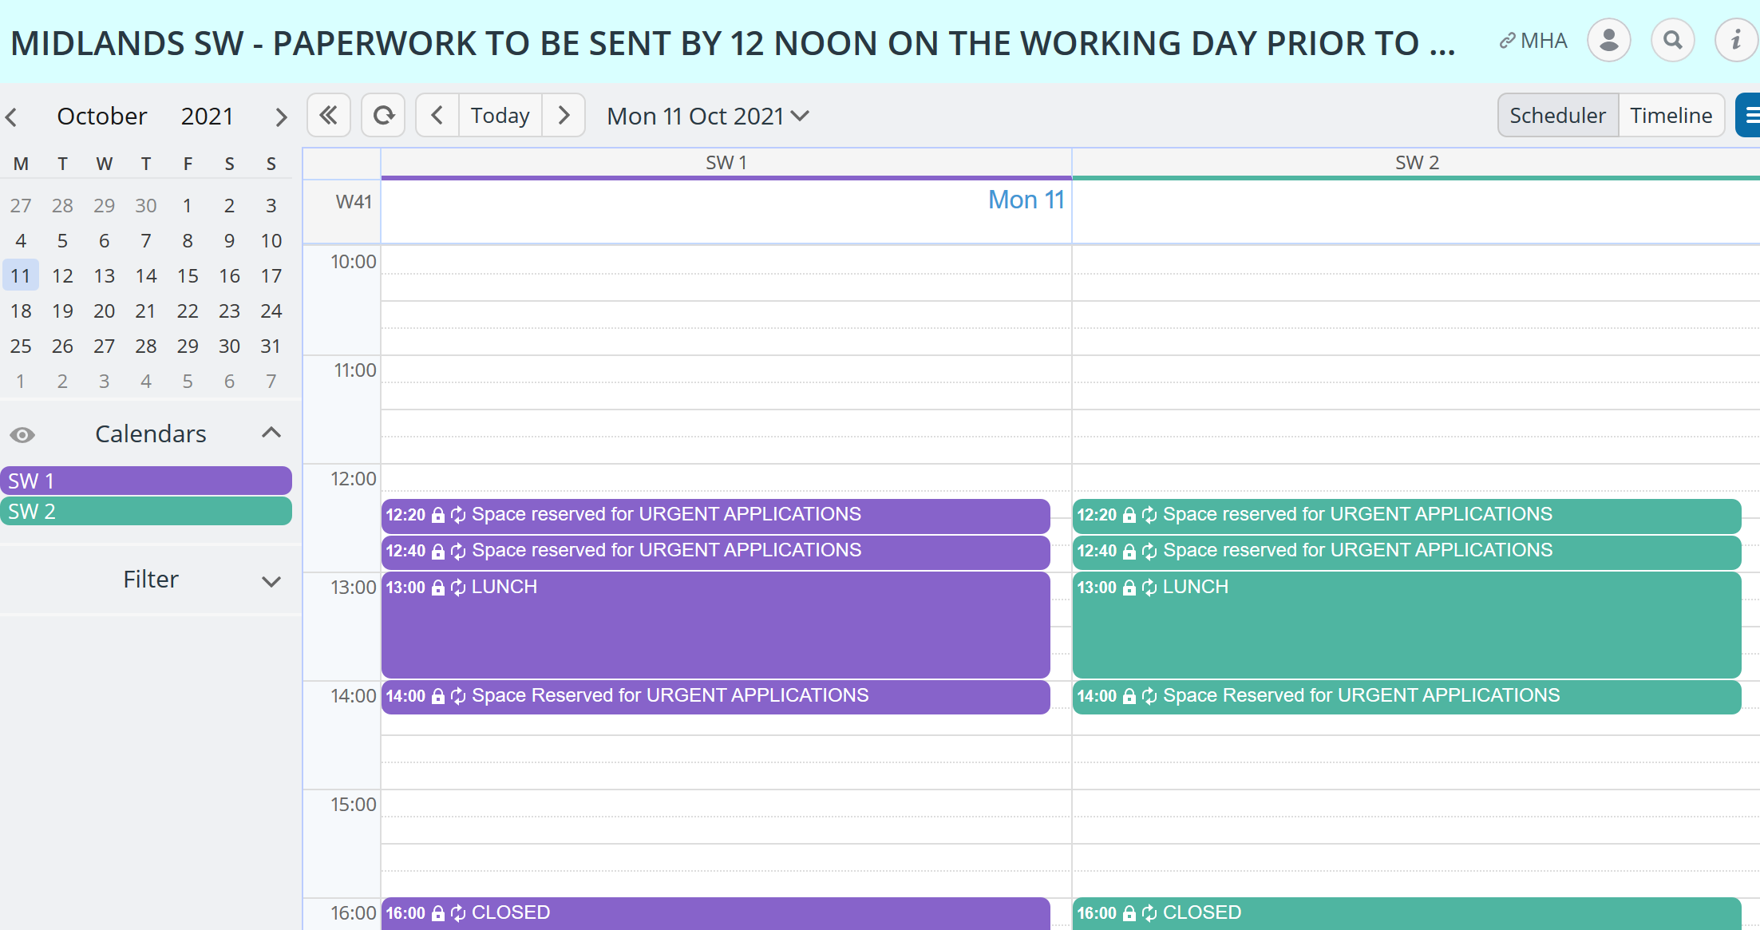

- SEARCHING FOR A DATE
You can select your preferred date for your application using the calendar function on the left hand side or the drop down menu from the top of the page. The search warrant courts that sit in the Midlands (titled SW1, SW2 and SW3) are colour coded purple, green and pink.

- BOOKING YOUR APPLICATION SLOT

Each search warrant slot is 20 minutes. The below image shows how the calendar appears, free slots are identified by the white spaces.

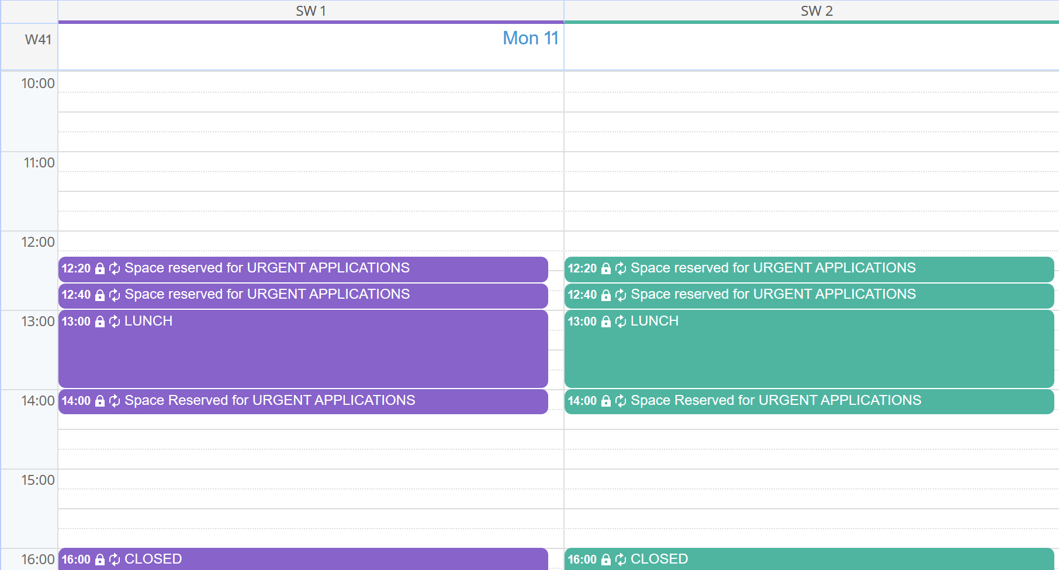

There are two calendars running each day (SW1 and SW2). On some days there is a third court SW3 also running.

The first slot each day is 10:00.

There will be no bookings allowed between 13:00 and 14:00.

There are 4 additional slots in each search warrant court at 12:20, 12:40, 14:00 and 16:00. These slots are reserved for Urgent Applications and can only be booked through request to HMCTS Administration (see point 11 of the protocol above)
Click on an empty slot at a suitable time and the pop-up window below will appear.

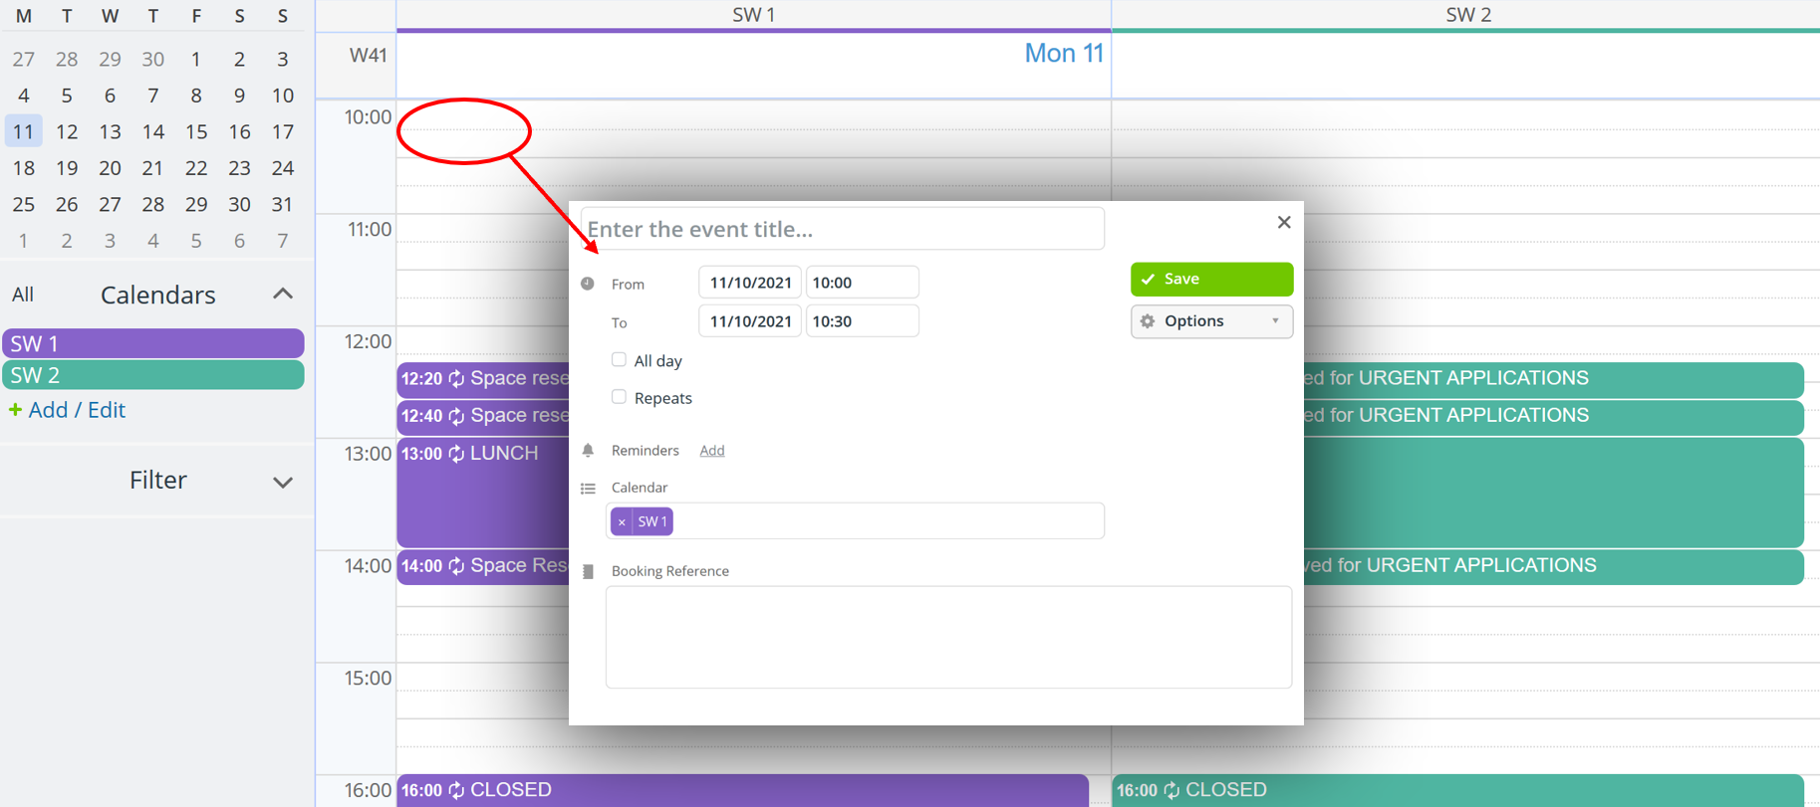

Complete the booking information in this window as follows:
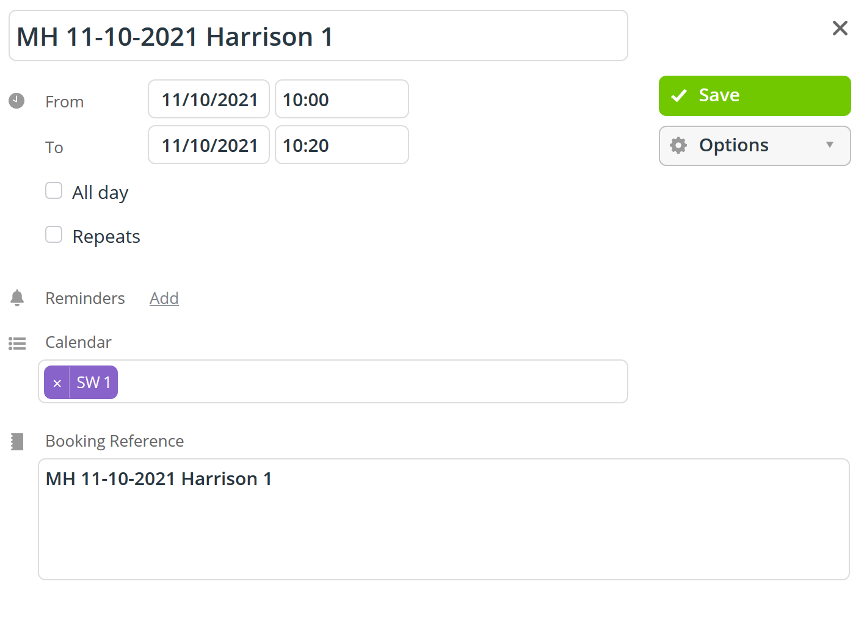

- Enter your booking reference using the naming convention below into both the ‘Enter the event title’ and ‘Booking Reference’ fields.

- Change the timing to a 20-minute hearing slot. All slots will default to 30 minutes when you click on them so you will need to change the ‘To’ field before you save (this is presuming that your application is for warrants in respect of up to 3 premises. If you seek warrants in respect of more premises then you will need to book an extra slot- see point 4 below).

- Take care NOT to click either the ‘All day’ or Repeats’ options. As the name suggests this will either make your booking take up the whole calendar for the day or be repeated every day thereafter.

- When you have double checked that the information entered is correct click ‘Save’

The calendar does not allow for overlapped bookings, therefore if you try to book a slot that has already been booked you will see the following error message:

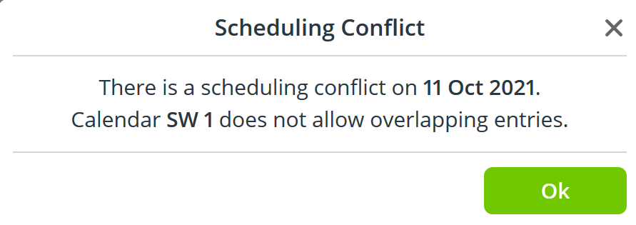

Click ok to remove the message and then reselect another time slot.

The calendar will allow for multiple users to be logged in at the same time using the same link, therefore it is possible that 2 applicants may be trying to book the same slot- if this occurs you will receive the same error message as above.

If another Police Force Area or another Applicant has made a booking in the calendar you will not be able to amend the time of that entry or delete it. This is indicated by the padlock icon against that calendar entry.

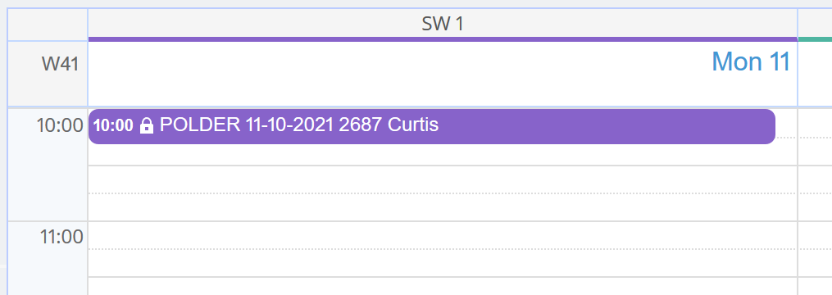

- THE TIMING OF YOUR APPLICATION

- Each Application slot is 20 minutes

- A 20-minute slot will accommodate 1 application for warrants in respect of up to 3 premises

- If your application is for more than 3 premises, then you will need to book a second slot to accommodate it

e.g. 1 application covering 5 premises as part of the same application: 20 mins + 20 mins = 40 mins

The Bookable Application times available are strictly set every 20 minutes as follows:

AM | PM
10:00 – 10:20 | (14:00 – 14:20 emergency slot- contact Admin)
10:20 – 10:40 | 14:20 – 14:40
10:40 – 11:00 | 14:40 – 15:00
11:00 – 11:20 | 15:00 – 15:20
11:20 – 11:40 Mid-morning break | 15:20 – 15:40
11:40 – 12:00 | 15:40 – 16:00
12:00 – 12:20 | (16:00 – 16:20 emergency slot- contact Admin)
(12:20 – 12:40 emergency slot- contact Admin)
(12:40 – 13:00 emergency slot- contact Admin)

Each Application must have a separate booking with a separate booking reference following the naming convention.

Each Application must have the same name as the warrant paperwork.

If more than 6 warrants are being applied for at the same time, supported by one application you should ring the emergency administrator number before booking in. The Administrator will then liaise with the Legal Adviser to best advise how the applications can be heard.

- YOUR BOOKING REFERENCE
The TeamUp Calendar is not a secure website. Nothing must be included in this calendar that identifies the premises to be searched or the occupier. Furthermore, there must be no information which could identify this as a police/court calendar (e.g. Officer’s rank, the words “police”, “warrant application”, “operation X” etc).’
The Court requires all applicants to adopt the booking reference system below:

LIST OF APPLICANT CODES FOR THE FIRST PART OF THE BOOKING REFERENCE

APPLICANT | CODE
Derbyshire Police | POLDER
Leicestershire Police | POLLEI
Lincolnshire Police | POLLIN
Mental Health Applicants | MH
National Crime Agency | HOMID
Northamptonshire Police | POLNOR
Nottinghamshire Police | POLNOT
Staffordshire Police | POLSTA
Warwickshire/ West Mercia Police | POLWAR
West Midlands Police | POLWM

- CANCELLING A BOOKING

- Before you have submitted your warrant paperwork to the court

To delete a booking, right click on the booking you wish to cancel and select Delete. You will be prompted by the pop-up window below to confirm that you do wish to delete your entry in the Calendar. Select Yes.

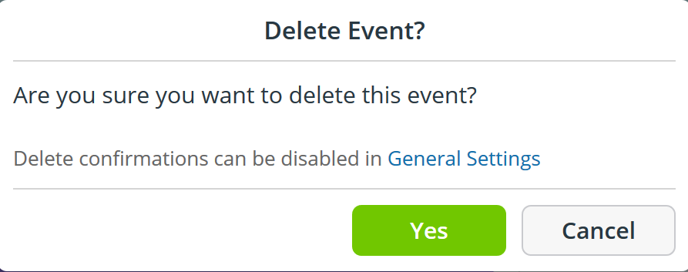

- After you have submitted your warrant paperwork to the court

You will need to follow the steps in (a) above to remove the entry from the TeamUp calendar but you will also need to inform the court. The Court has received your paperwork and time will be wasted by the Legal Adviser and the Magistrate reading this paperwork unless the Court is notified by you that you have cancelled the booking.

Please send an email to DN-SearchWarrants@justice.gov.uk confirming Cancellation of your booking and include the Booking Reference within the Subject Line of the email.

Annex- Pro Forma Applications and warrants

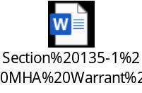

Figure 1- Application s135 (1) MHA 1983 – Search for and Removal of PERSON

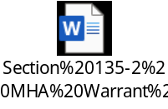

Figure 3- Application s135 (2) MHA 1983 – Search for and Removal of PATIENT

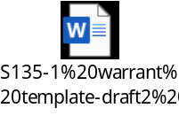

Figure 2- Warrant s135 (1) MHA 1983 Search for and Removal of PERSON

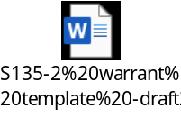

Figure 4- Warrant s135 (2) MHA 1983 – Search for and Removal of PATIENT

